**Git Repository Guide for Windows User**

# Section 1: Local configuration

## 1. Install TortoiseGit

(You can also ask me to copy, the Chinese package needs to be installed separately)

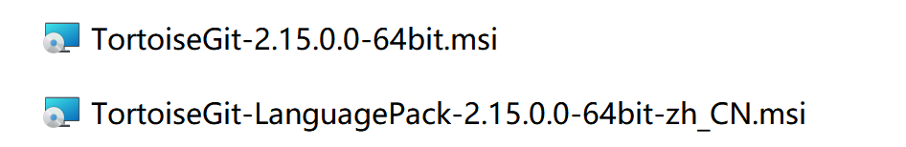

Download path<https://tortoisegit.org/download/>

The language pack of tortoiseGit needs to be downloaded separately, and the default language of the installation package is English.

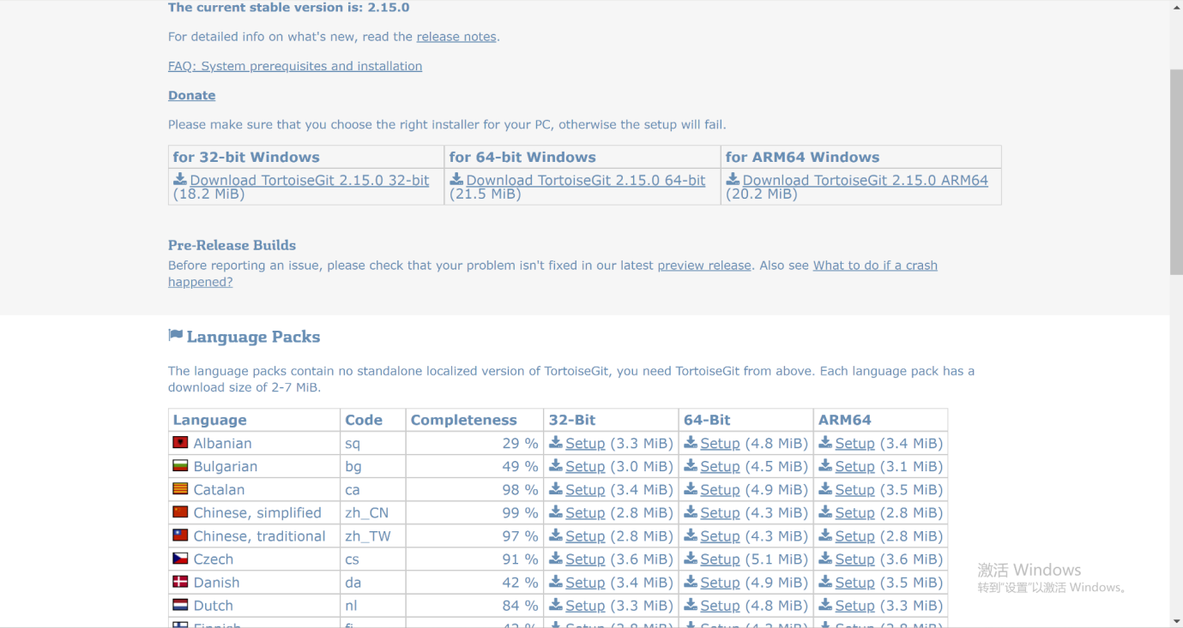

Fill in your own account during the installation process, it will be useful later

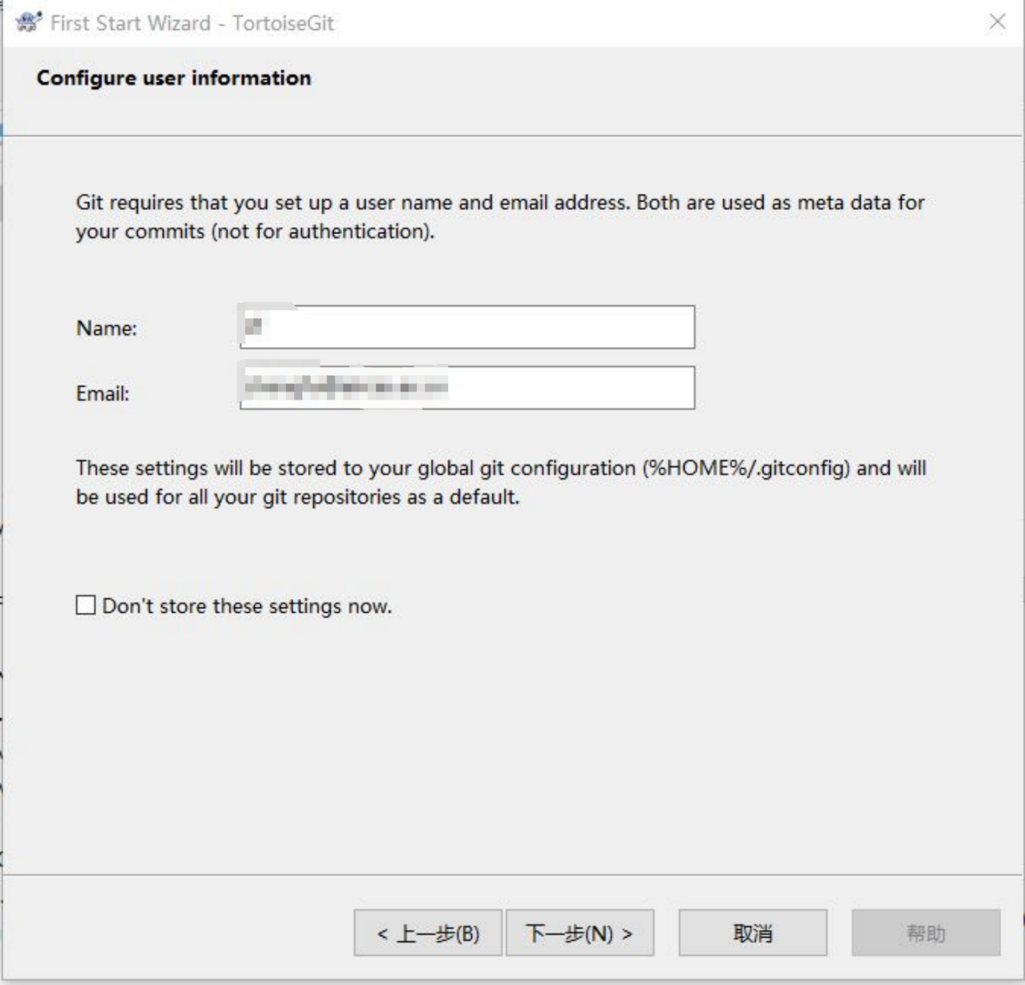

## 2. TortoiseGit configuration

1. Select a directory to store Git projects and open it in the resource manager

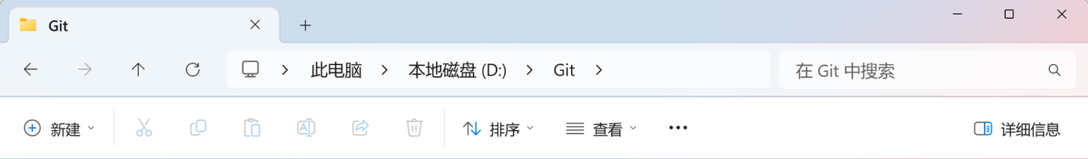

1. Right-click on the blank space and select → TortoiseGit → Settings to open the configuration interface

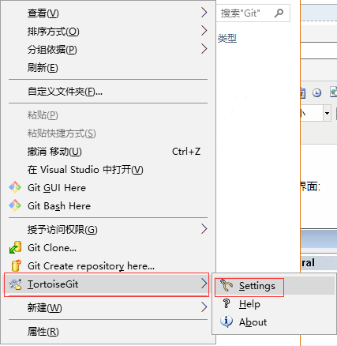

1. Select the General card to adjust the language and specify the path to the git.exe file.

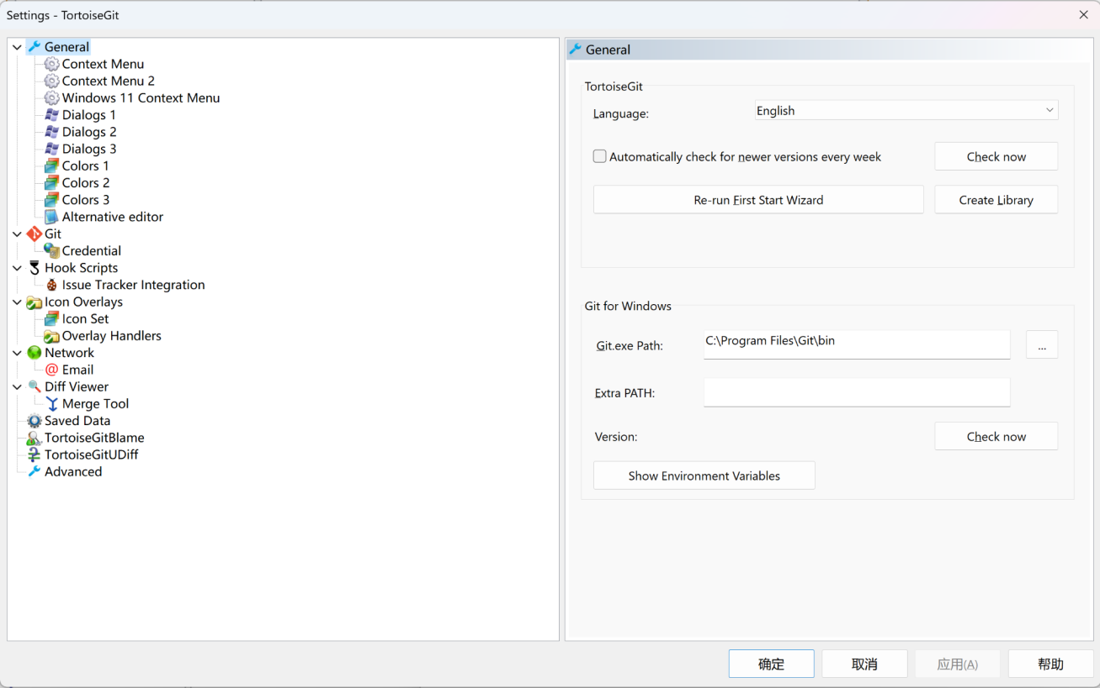

1. Configure users. Go to Settings → Git Card and configure username and email.

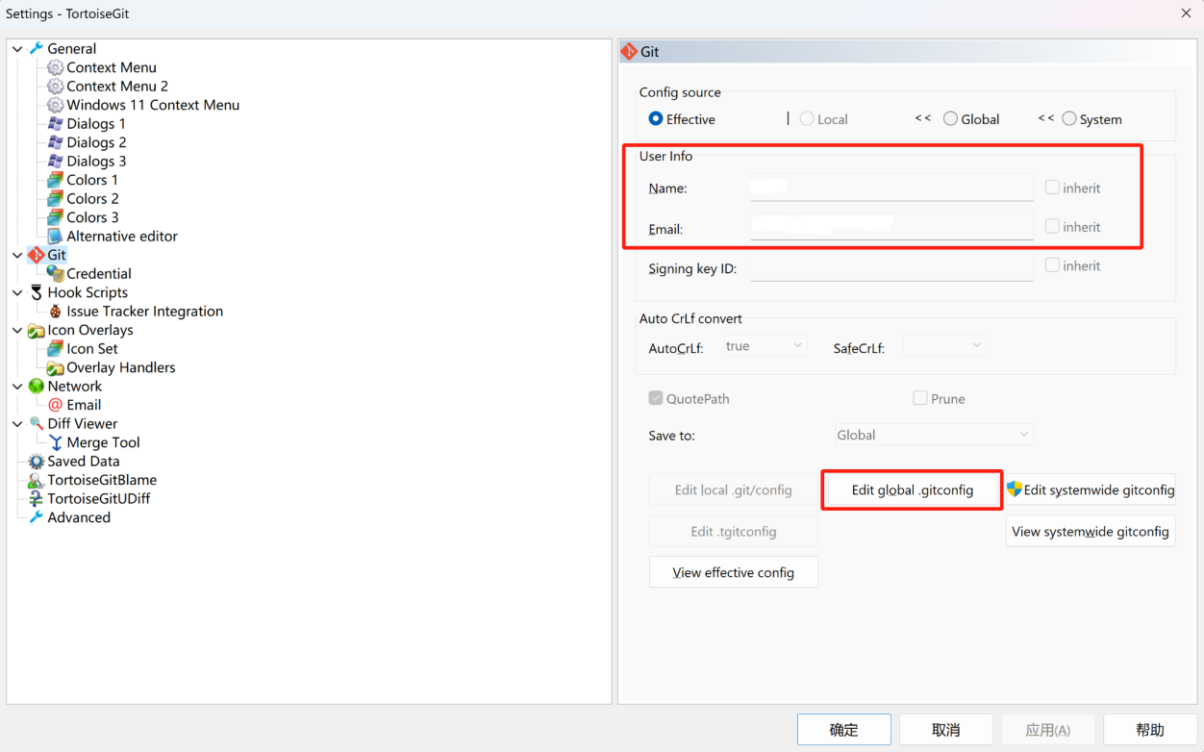

Click the "Edit.git/config(O)" button, the global configuration file will be opened using Notepad, and the following content will be added at the end:

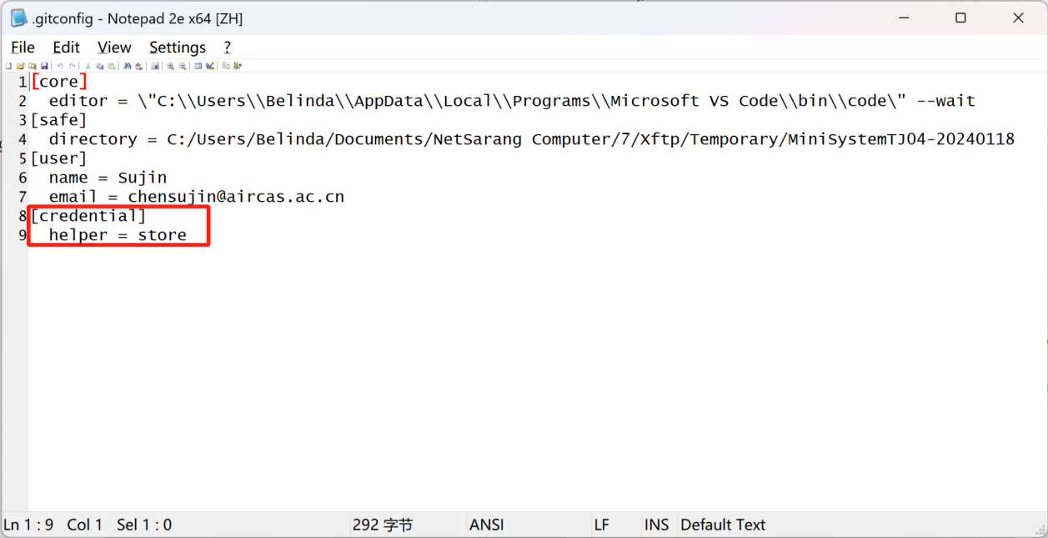

When finished, save it, close Notepad, and confirm.

## 3. TortoiseGit usage

Use SSH to submit and clone code.

1. To use SSH URL transmission, you need to configure the local SSH public key on the Git server first.

Check the SSH key first. In the user's home directory on drive C, check whether there is an .ssh directory. If so, check whether there are two files, id_rsa and id_rsa.pub. If you already have these two files, jump directly to step two.

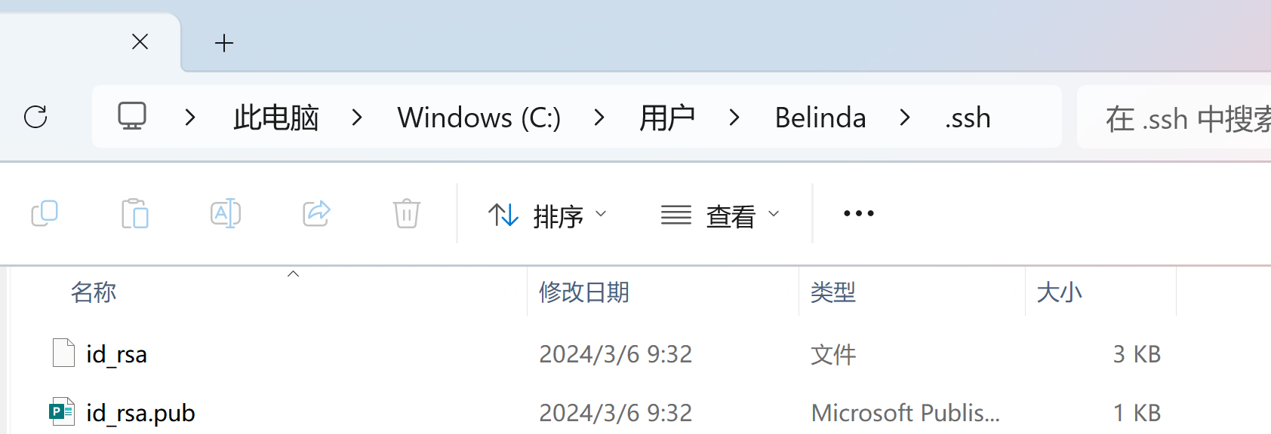

If you do not have the above files, you need to create an SSH Key.Right-click in any folder and select Git GUI Here. In the pop-up program, select Help → Show SSH Key from the main menu.

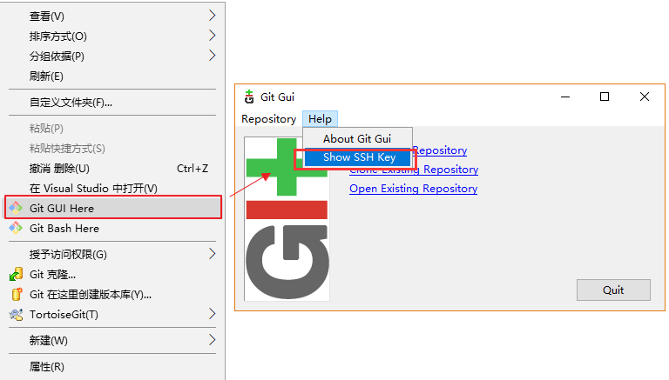

If there is no key, click Generate Key to generate an SSH Key.

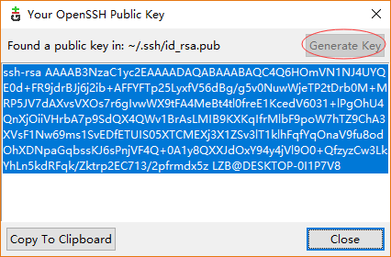

After completion, there will be a .ssh directory in the user's home directory, which contains two files, id_rsa and id_rsa.pub. These two are the key pairs of the SSH Key. id_rsa is the private key and id_rsa.pub is the public key.

1. Send the SSH Key to the administrator and fill it in the Git server configuration.
2. Right-click on an empty location in the local folder and select Git Clone from the menu.

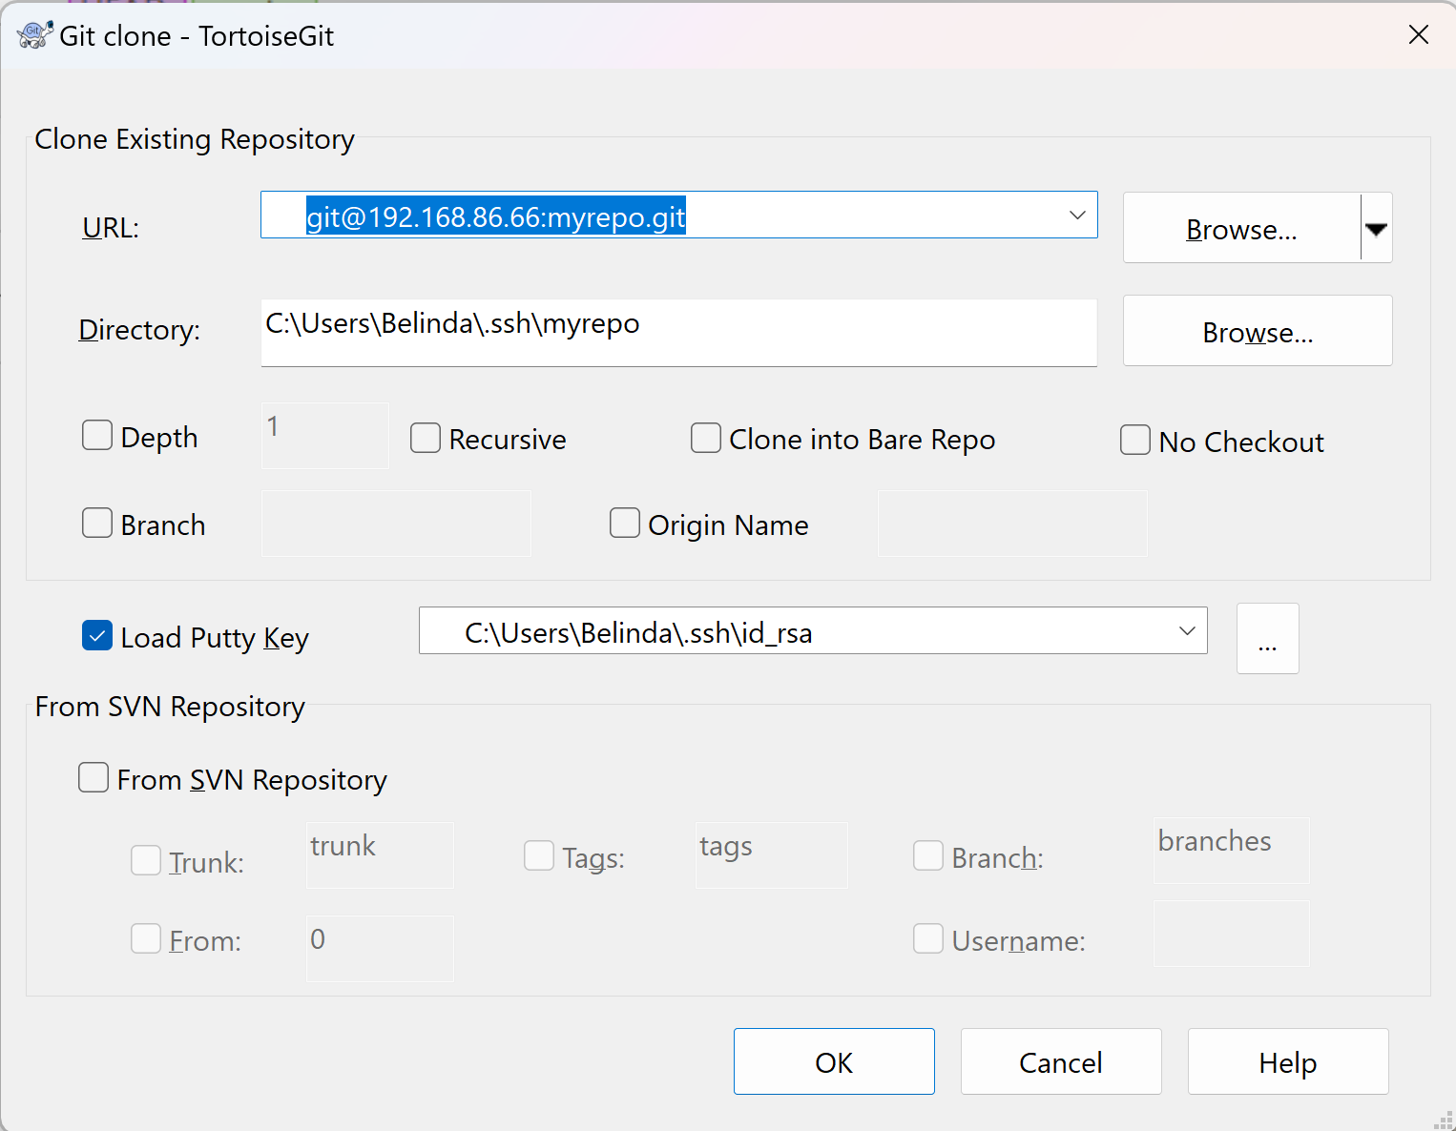

Fill in the git path to the URL, select the local file directory, and click OK. (There must be at least one file on the server side, otherwise an error "fatal: Couldn't find remote ref HEAD" will be reported when pulling)

The cloning was successful as shown below:

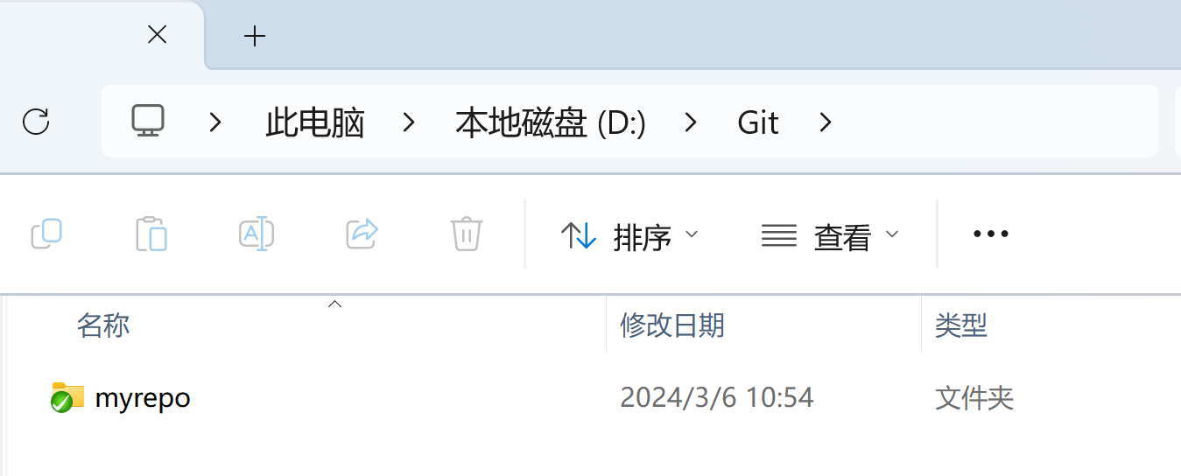

1. Submit code.

Right-click the blank space of the local project and select Git Submit → master…

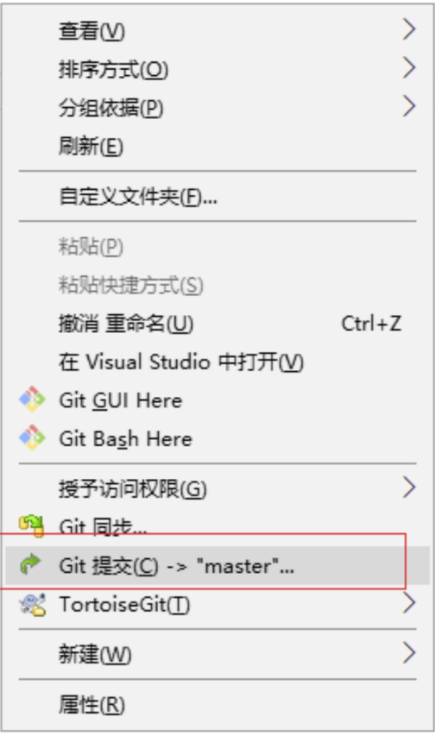

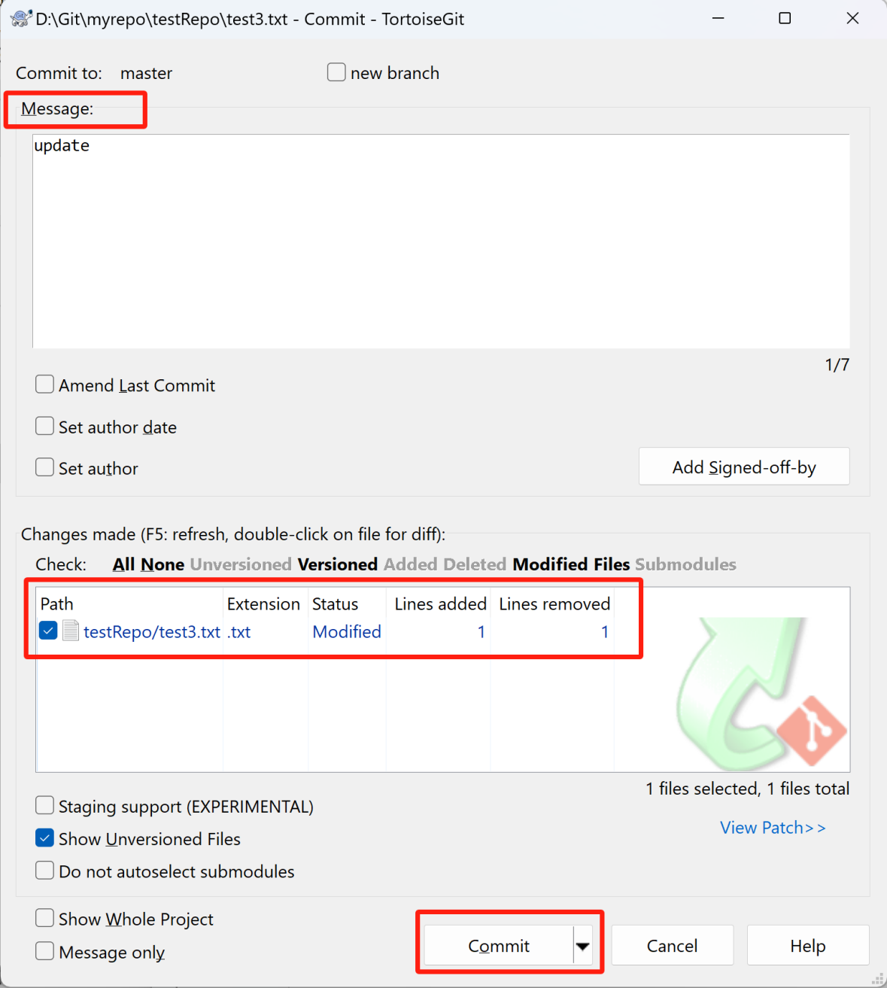

The message must be filled in before it can be submitted. Select the changes you want to submit and click commit.

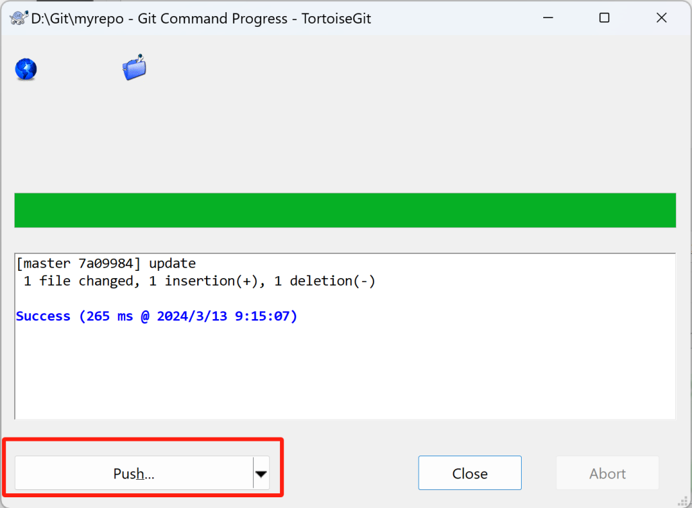

1. Push the code to the server.

After the submission is successful, the modifications in the local warehouse need to be pushed to the remote warehouse.

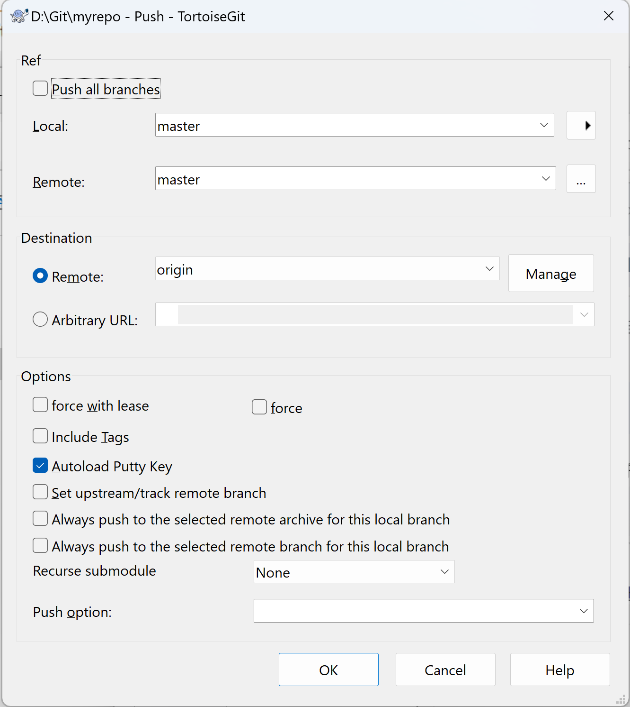

Submission successful.

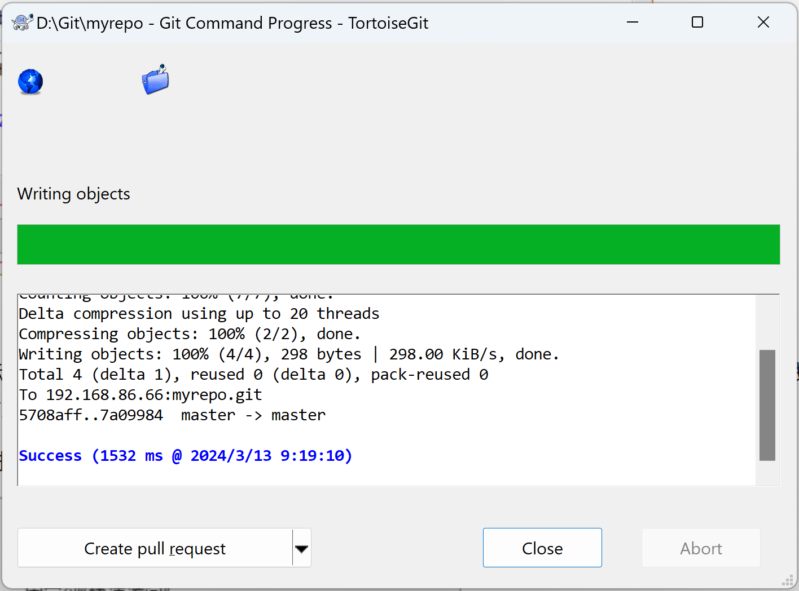

1. Pull the code from the server.

Right-click on the git folder → Git Sync…/Git Sync…, open the dialog box, and click pull.If the file on the server has not been modified, it will directly prompt that the update has been successful.

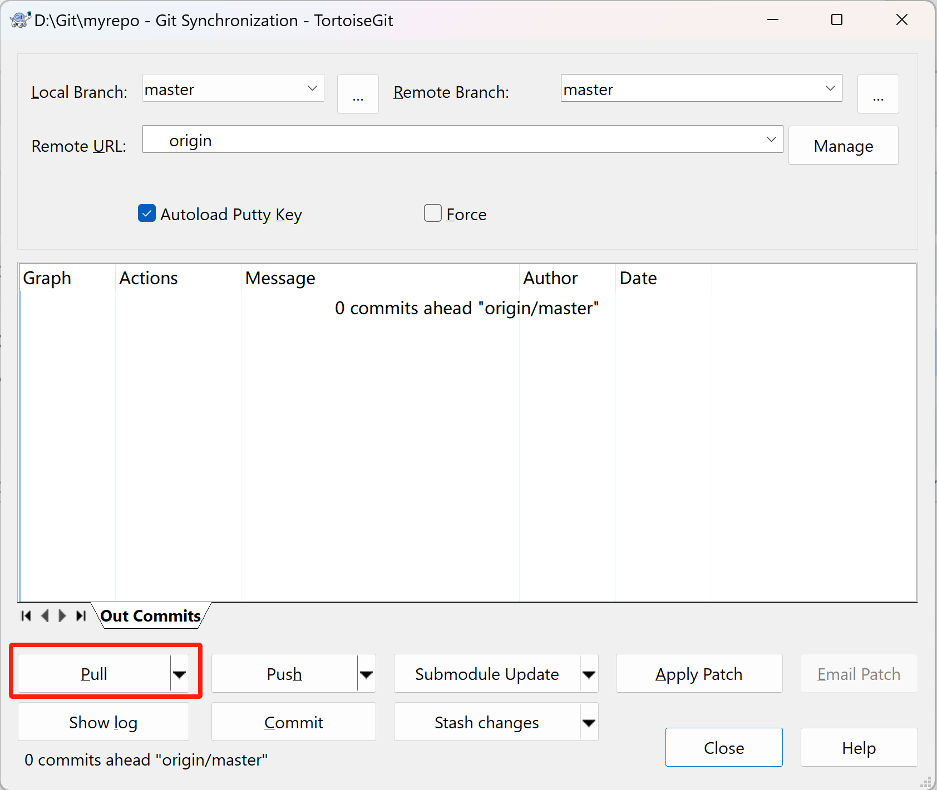

If the file on the server has been modified before submitting the file, and the local file is not the latest version before modification, a conflict will be prompted, and the conflict needs to be resolved before submitting the modification result.

Select the conflict item on the conflict page, right-click to resolve the conflict, click submit again, and push to the remote warehouse.

## 4. Private key configuration, no need to enter password

Find PuTTYgen under the installed TortoiseGit and open it



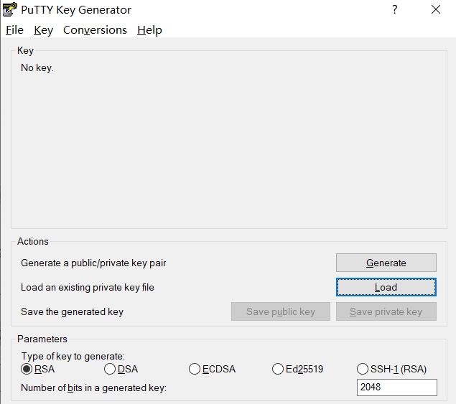

Select the load private key file id_rsa, and then click Save private key to generate the xxx.ppk file. You can name it whatever you want.

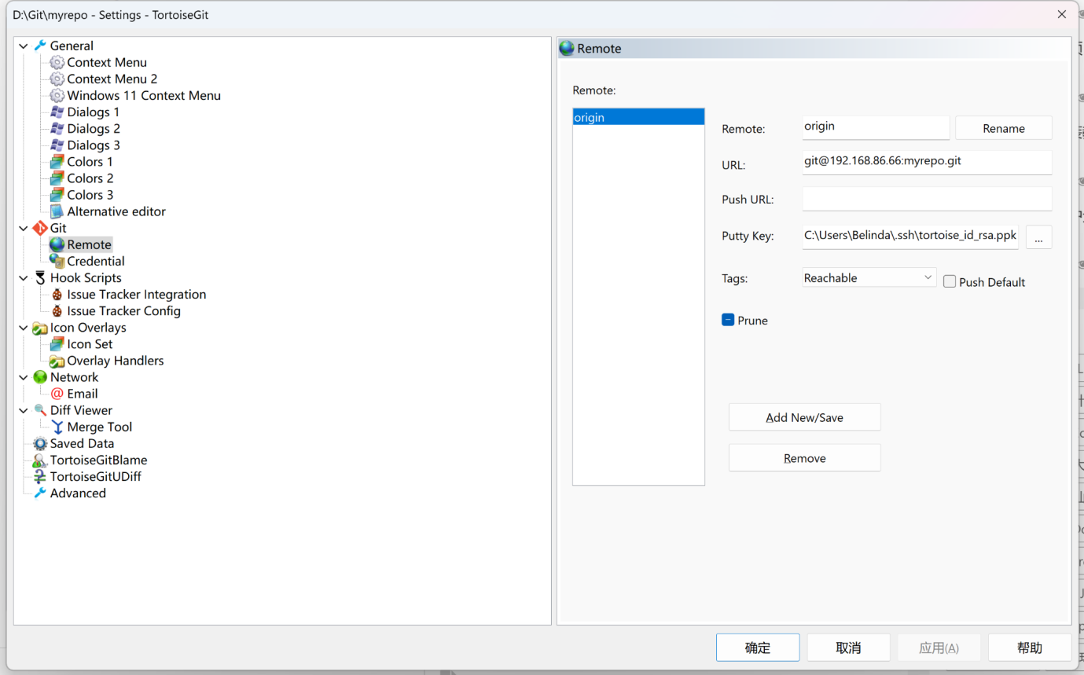

Check Autoload Putty Key during synchronization so you don’t have to enter your password every time.

# Section 2: Local folder icon display problem handling

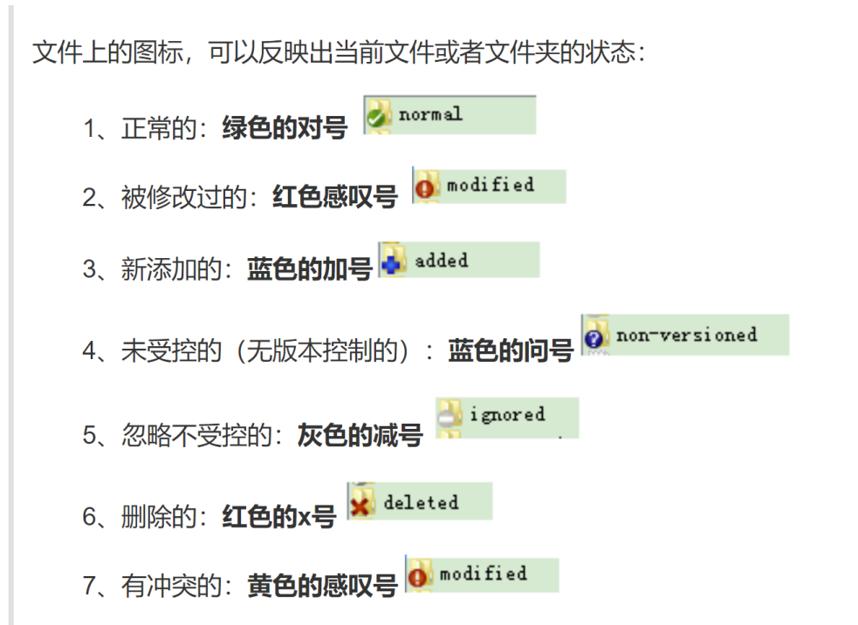

After installing git, the problem that the managed files do not have colored prompt icons is solved:

1. Modify registry

Win+R opens the run window and enter regedit.exe

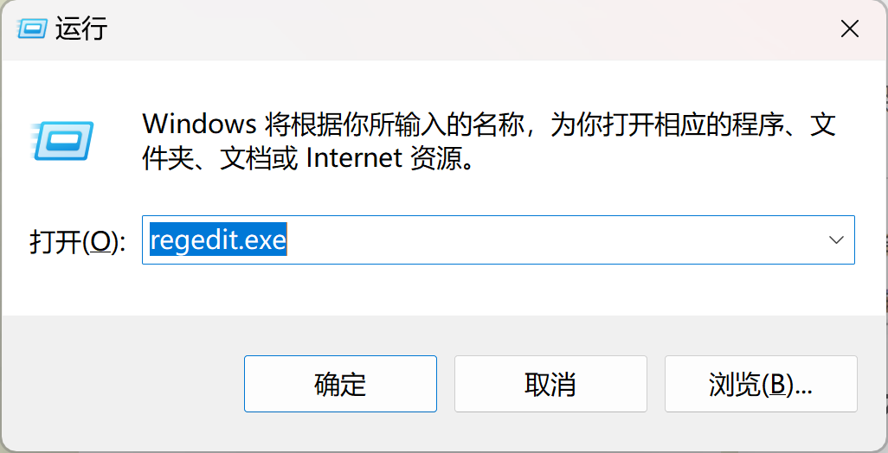

1. try to findHKEY_LOCAL_MACHINE\Software\Microsoft\windows\CurrentVersion\Explorerpath

If there is no Max Cached Icons option in the folder, create a new string value, name it Max Cashed Icons, and set the numerical value to 2000.

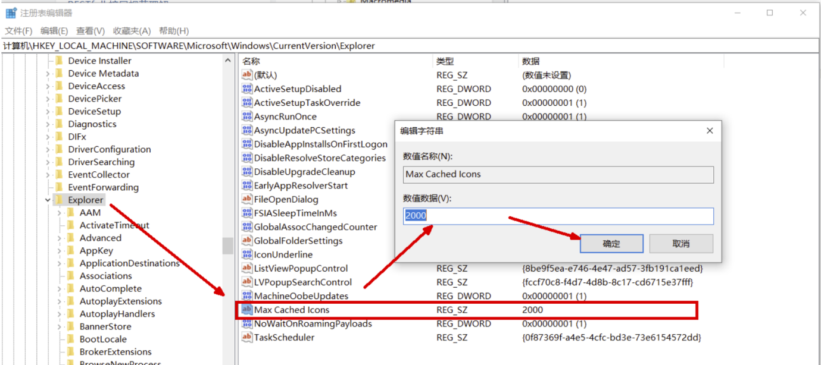

Restart the computer for the changes to take effect.

1. If it still doesn't work after changing the previous ones, rename several folders related to Tortoise in the registry (add a few spaces at the front), move them to the top, save and close the registry.

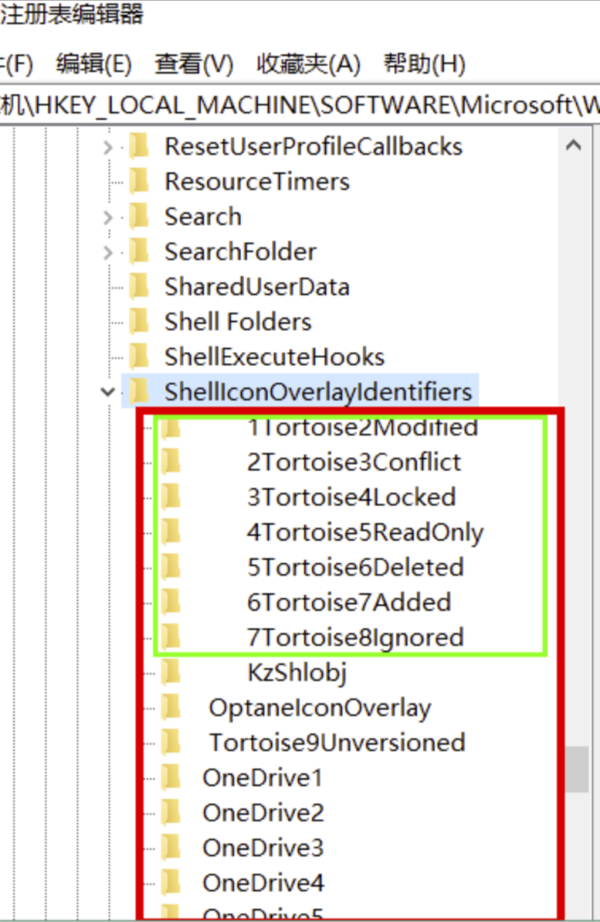

# Section 3: TortoiseGit uses

## 1. Branch fusion branch → merge to master branch

<https://blog.csdn.net/github_38924695/article/details/137044251>

## 2. Conflict resolution

There is a conflict in push → pull → resolve → commit

The log records local commit records, including conflicting modified versions and pulled versions.

## 3. Restore local to historical version

Right-click the historical version you want to restore to → reset master to…

Selecting hard mode will change the version currently in use.

## 4. Version comparison

Right-click the folder → TortoiseGit → show log to open the log interface

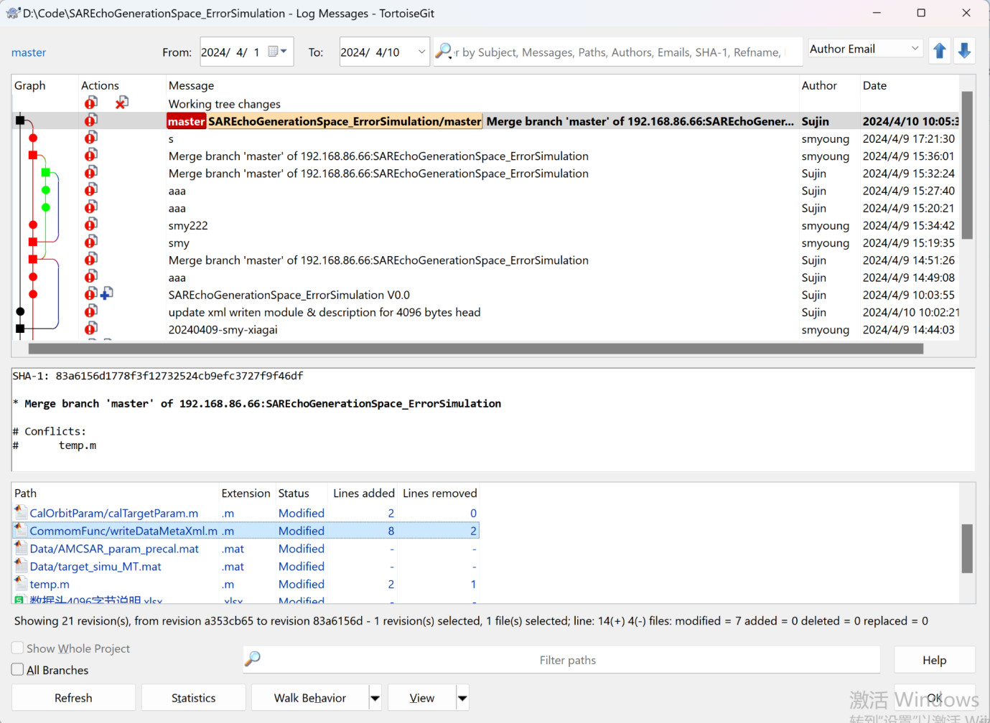

Select the document you want to compare, right-click → compare with base

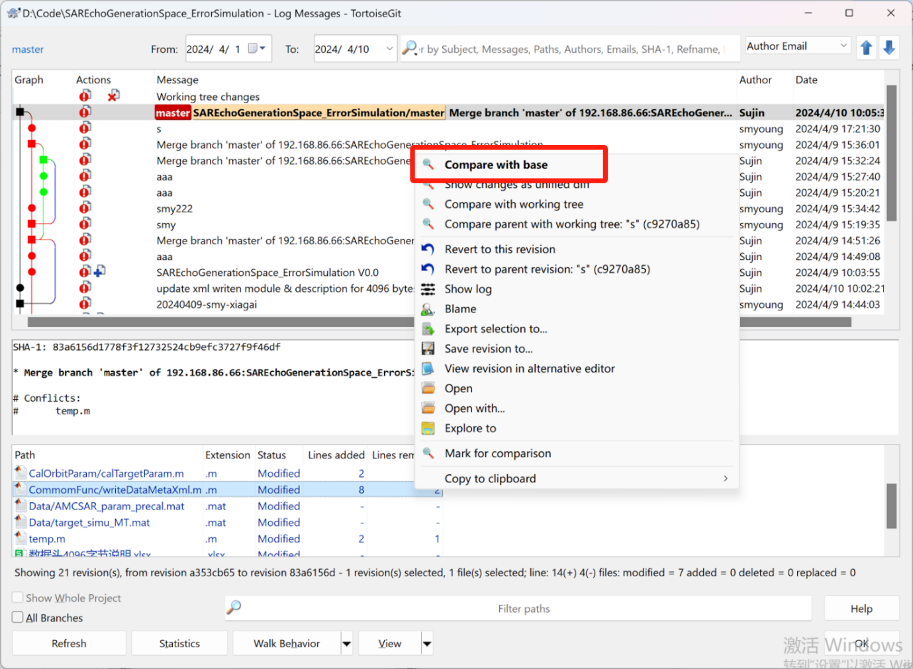

Opens a comparison window between the updated version of the document and the current baseline version

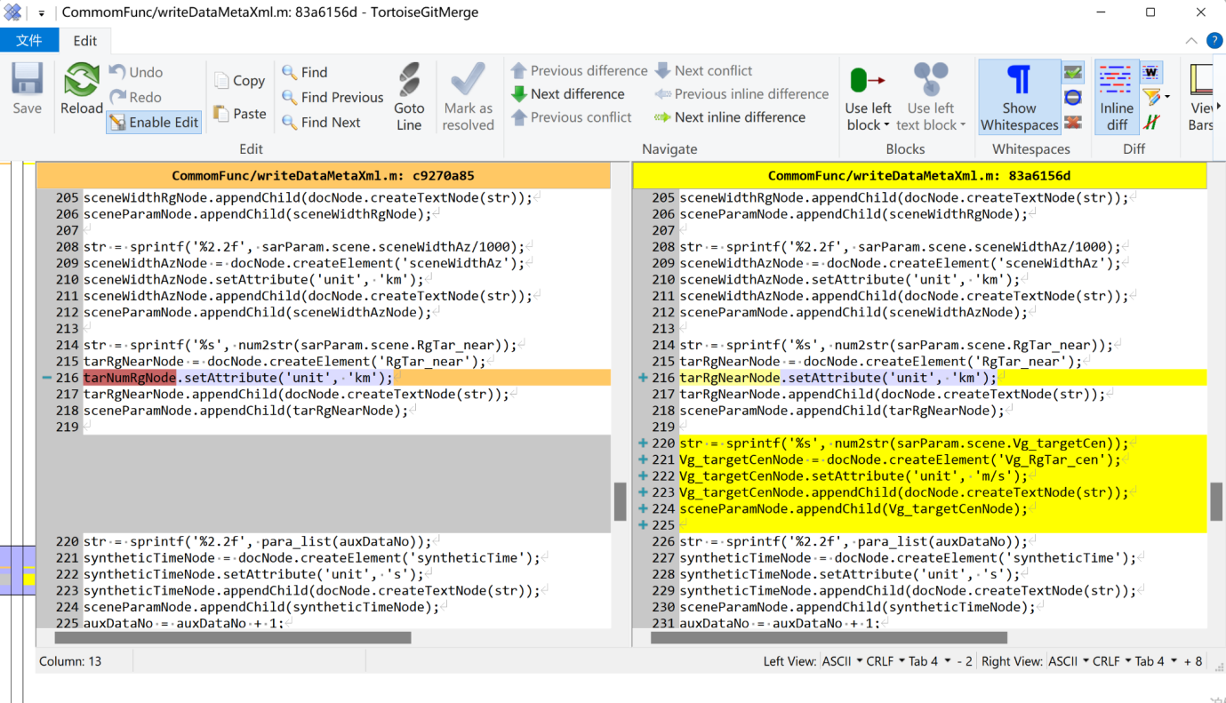

## PS: About [Git] push failure and some error solutions when using TortoiseGit（Links in Chinese）

<https://blog.csdn.net/nanmiao666/article/details/131143592>

<https://support.huaweicloud.com/ecs_faq/ecs_faq_0556.html>